**SERVICIO NACIONAL DE APRENDIZAJE SENA**

**TECNOLOGIA EN ANALISIS Y DESARROLLO DE SOFTWARE**

**ADSO**

**NUMERO DE LA FICHA: 2721554**

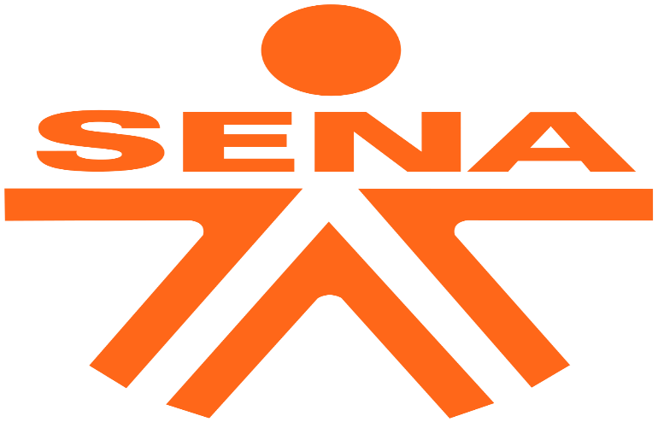

**NOMBRE DE LA EVIDENCIA:**

**DOCUMENTO ESCRITO GA2-240202501-AA2-EV03**

**APRENDIZ**

**MARVIN MARIN CERA**

**SOLEDAD, ATLANTICO**

**AÑO: 2023**

Title: **Subject: Application for Software Developer Position**

Dear: **DEVELOPER SOFTWARE TEAM SENA**

Good Moring, cordial Greetings, I am writing to apply for the software developer position advertised in the Systems section of your company. With a strong background in web development and a passion for creating innovative solutions, I believe I would be a valuable asset to your organization.

As a creative, responsible, proactive, honest, and dedicated professional, I am eager to contribute with my skills and expertise to the success and continuous improvement of your company. I am committed to executing my duties diligently and fostering positive working relationships within the team.

I have a proven track record in web development and analysis, with proficiency in various programming languages and frameworks such as HTML, CSS, JavaScript, and React. My experience includes designing and developing user-friendly websites, conducting thorough testing to ensure functionality and optimal performance, and collaborating with cross-functional teams to deliver successful projects.

In addition to my technical abilities, I strongly believe in the importance of attitude and a sense of belonging in the workplace. I strive to maintain a positive and enthusiastic approach to my work, always seeking opportunities to learn and grow. I am confident that my experience, along with my friendly and approachable nature, would allow me to make valuable contributions to your team.

Thank you for considering my application. I have attached my resume for your review. I would welcome the opportunity to further discuss how my skills and qualifications align with your company's requirements. Please feel free to reach out to me at your convenience.

Thank you once again for your time and consideration.

Sincerely,

**MARVIN MARIN CERA**

**3135059474**

**SOLEDAD, ATLANTICO**